**DAY4 NAME: SREE SANTHIKRISHNA S**

**ROLL NO: 727721eucs149**

**CLASS EXERCISE 1 :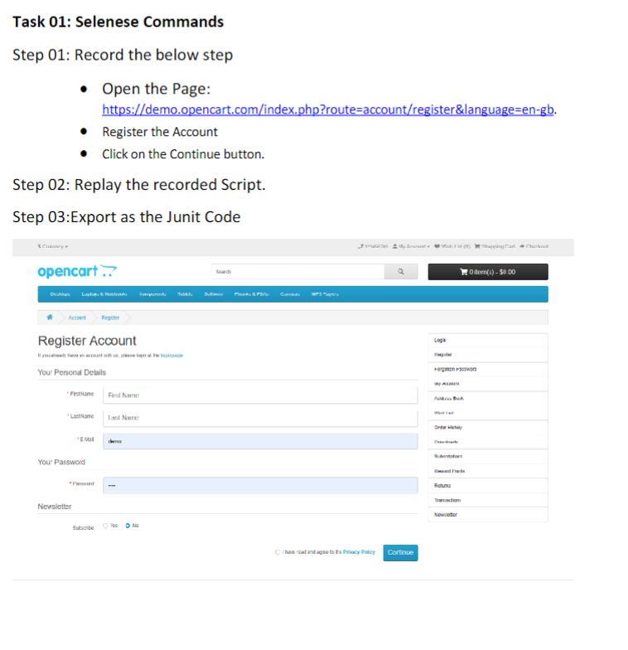   
OUTPUT :**

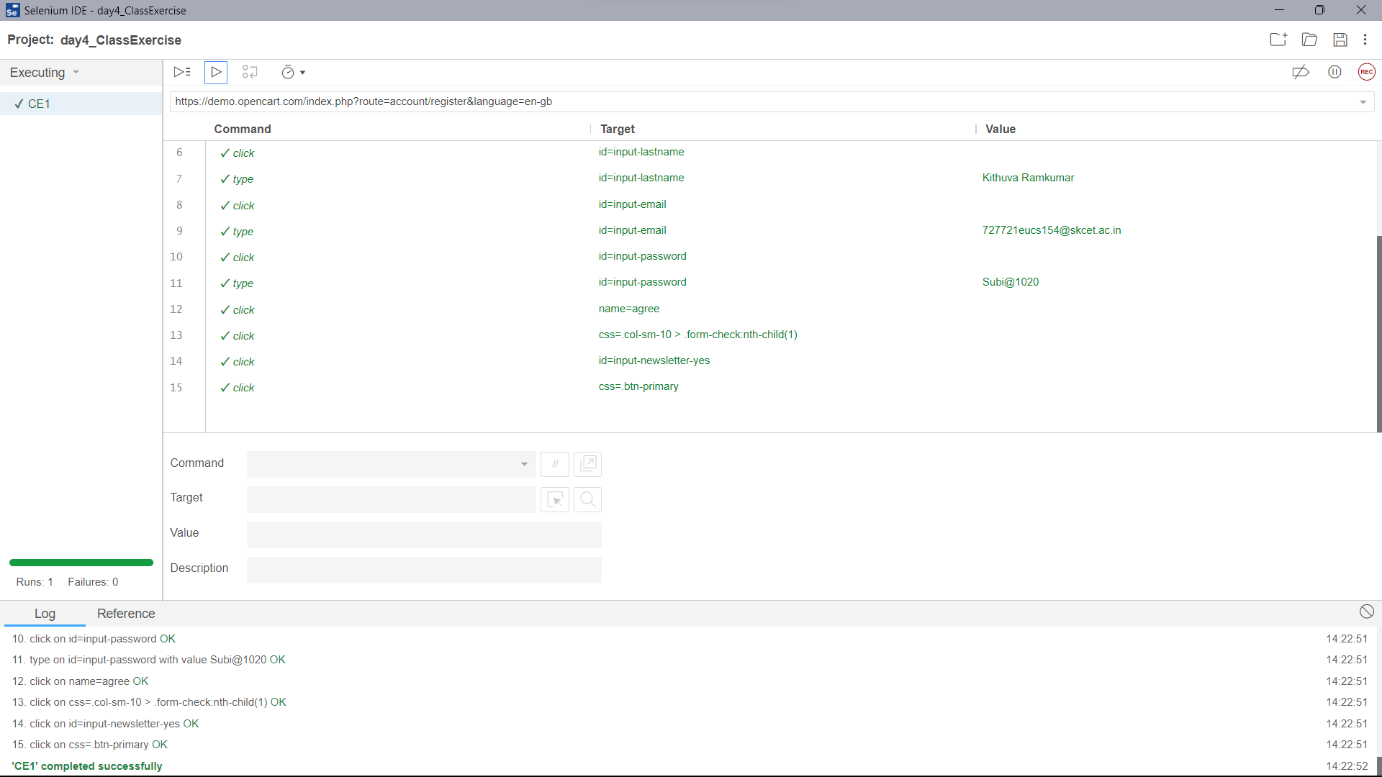

**CLASS EXERCISE 2 :**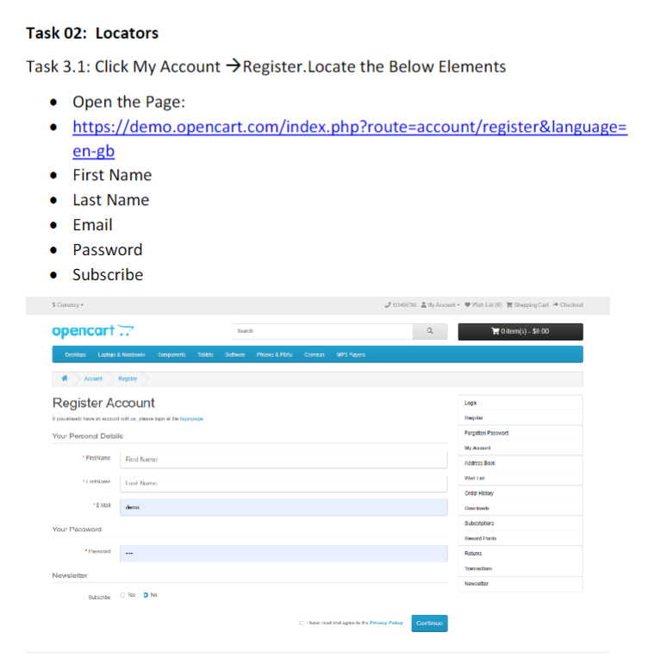

**CODE :**

package com.day4;

import org.openqa.selenium.By;

import org.openqa.selenium.WebDriver;

import org.openqa.selenium.WebElement;

import org.openqa.selenium.chrome.ChromeDriver;

import org.openqa.selenium.chrome.ChromeOptions;

import io.github.bonigarcia.wdm.WebDriverManager;

public class CE_2 {

public static void main(String[] args) throws InterruptedException {

ChromeOptions co = new ChromeOptions();

co.addArguments("--remote-allow-origins=*");

WebDriverManager.chromedriver().setup();

WebDriver driver = new ChromeDriver();

driver.get("https://demo.opencart.com/index.php?route=account/register&language=en-gb");

driver.manage().window().maximize();

WebElement fname = driver.findElement(By.id("input-firstname"));

fname.sendKeys("Subiksha");

WebElement lname = driver.findElement(By.id("input-lastname"));

lname.sendKeys("K R");

WebElement email = driver.findElement(By.id("input-email"));

email.sendKeys("727721eucs154@skcet.ac.in");

WebElement pw = driver.findElement(By.id("input-password"));

pw.sendKeys("Subi2003");

Thread.sleep(2000);

driver.findElement(By.id("input-newsletter-yes")).click();

Thread.sleep(3000);

driver.findElement(By.name("agree")).click();

Thread.sleep(1000);

driver.findElement(By.xpath("//button[@type=\"submit\"]")).click();

}

} **OUTPUT :**

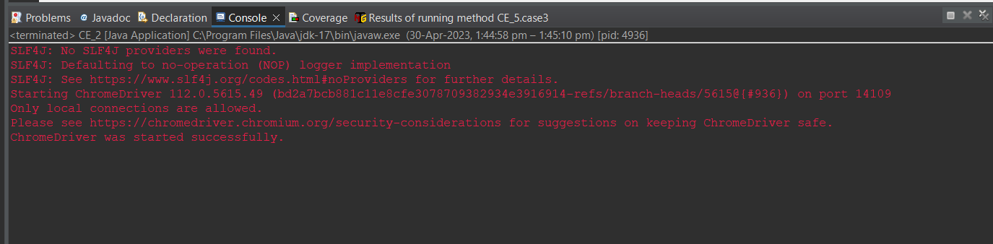

**CLASS EXERCISE 3 :**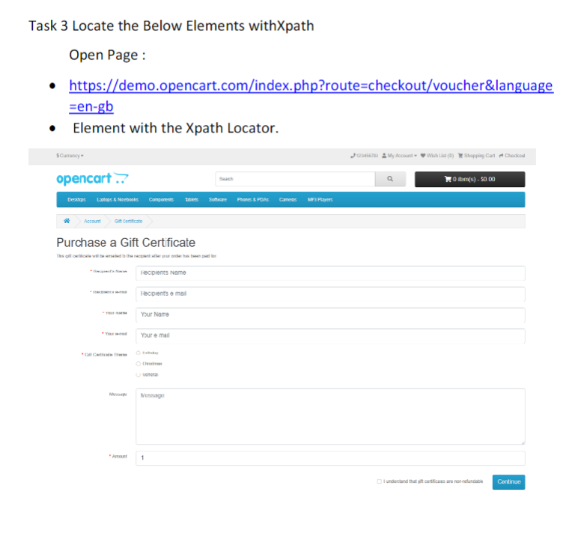

**CODE :**

package com.day4;

import org.openqa.selenium.By;

import org.openqa.selenium.WebDriver;

import org.openqa.selenium.WebElement;

import org.openqa.selenium.chrome.ChromeDriver;

import org.openqa.selenium.chrome.ChromeOptions;

import io.github.bonigarcia.wdm.WebDriverManager;

public class CE_3 {

public static void main(String[] args) throws InterruptedException {

ChromeOptions co = new ChromeOptions();

co.addArguments("--remote-allow-origins=*");

WebDriverManager.chromedriver().setup();

WebDriver driver = new ChromeDriver();

driver.get("https://demo.opencart.com/index.php?route=checkout/voucher&language=en-gb");

driver.manage().window().maximize();

WebElement Rname = driver.findElement(By.xpath("/html/body/main/div[2]/div/div/form/div[1]/div/input"));

Rname.sendKeys("Sowndarya");

WebElement Remail = driver.findElement(By.xpath("/html/body/main/div[2]/div/div/form/div[2]/div/input"));

Remail.sendKeys("Sowndaryainduja@gmail.com");

WebElement MyName = driver.findElement(By.xpath("/html/body/main/div[2]/div/div/form/div[3]/div/input")); // this is absolute .. copy full xpath

MyName.sendKeys("Subiksha");

WebElement MyEmail = driver.findElement(By.xpath("//*[@id=\"input-from-email\"]")); // this is realtive ..copy xpath

MyEmail.sendKeys("Subi2003@gmail.com");

Thread.sleep(1000); driver.findElement(By.xpath("/html/body/main/div[2]/div/div/form/div[5]/div/div[1]/div[3]/input")).click();

WebElement Mssg = driver.findElement(By.xpath("/html/body/main/div[2]/div/div/form/div[6]/div/textarea"));

Mssg.sendKeys("Hello Sowndarya.. You are such an Optimistic person. I like your thoughts . Vaadi Pathukalam minded person . So I am giving you a present");

WebElement amount = driver.findElement(By.xpath("/html/body/main/div[2]/div/div/form/div[7]/div/input"));

amount.clear();

amount.sendKeys("1000");

Thread.sleep(1000);

driver.findElement(By.xpath("/html/body/main/div[2]/div/div/form/div[8]/div/div/input")).click();

Thread.sleep(1000);

driver.findElement(By.xpath("/html/body/main/div[2]/div/div/form/div[8]/div/button")).click();

}

} **OUTPUT :**

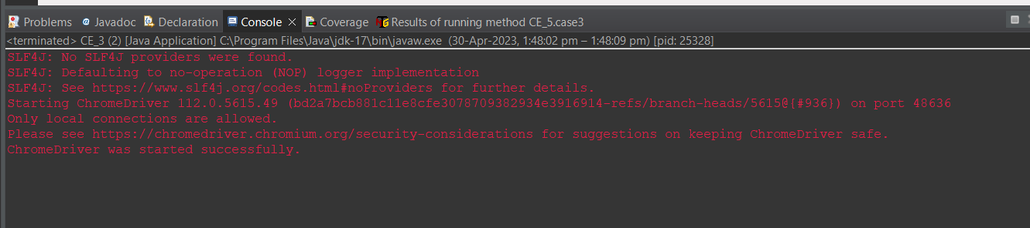

**CLASS EXERCISE 4 :**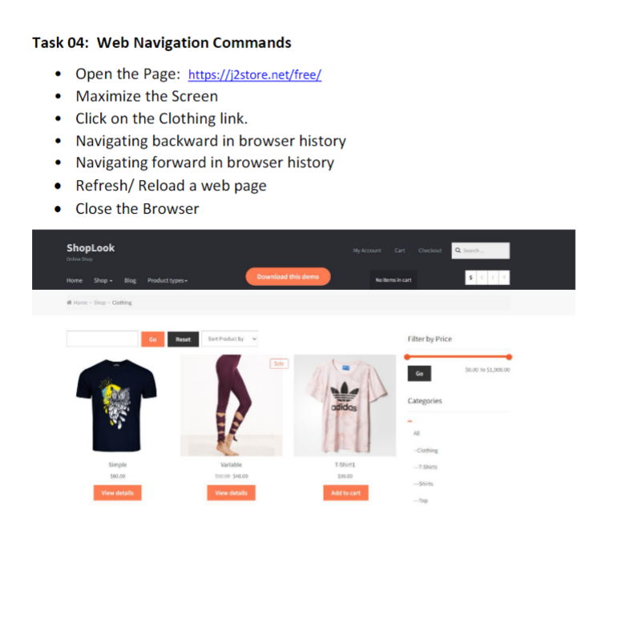

**CODE :**

package com.day4;

import org.openqa.selenium.By;

import org.openqa.selenium.WebDriver;

import org.openqa.selenium.chrome.ChromeDriver;

import org.openqa.selenium.chrome.ChromeOptions;

import io.github.bonigarcia.wdm.WebDriverManager;

public class CE_4 {

public static void main(String[] args) {

ChromeOptions co = new ChromeOptions();

co.addArguments("--remote-allow-origins=*");

WebDriverManager.chromedriver().setup();

WebDriver driver = new ChromeDriver();

driver.navigate().to("https://j2store.net/free/");

driver.manage().window().maximize();

driver.findElement(By.linkText("Clothing (5)")).click();

driver.navigate().back();

driver.navigate().forward();

driver.navigate().refresh();

driver.close();

}

} **OUTPUT :**

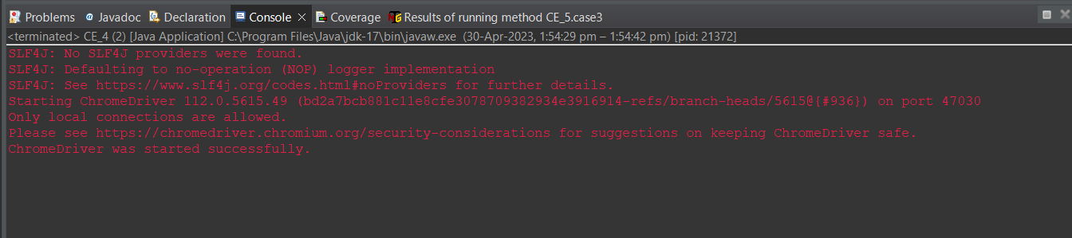

**CLASS EXERCISE 5:**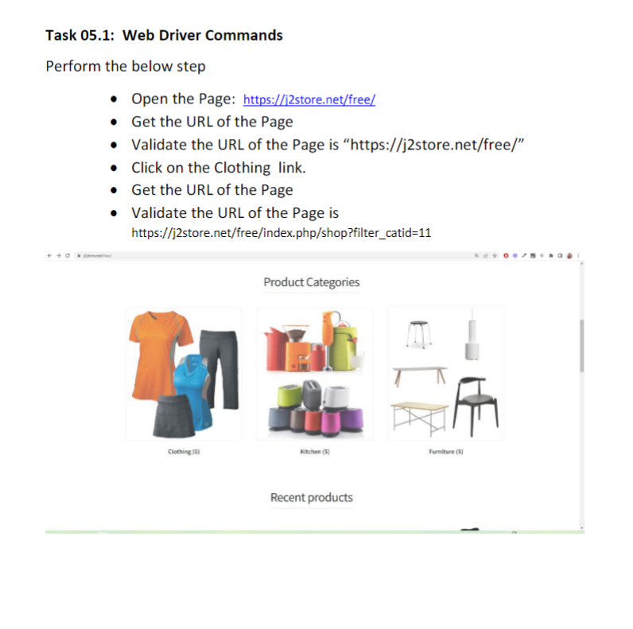

**CODE :**

package com.day4;

import org.openqa.selenium.By;

import org.openqa.selenium.WebDriver;

import org.openqa.selenium.WebElement;

import org.openqa.selenium.chrome.ChromeDriver;

import org.openqa.selenium.chrome.ChromeOptions;

import io.github.bonigarcia.wdm.WebDriverManager;

public class CE_5 {

public static void main(String[] args) {

ChromeOptions co = new ChromeOptions();

co.addArguments("--remote-allows-origins=*");

WebDriverManager.chromedriver().setup();

WebDriver driver = new ChromeDriver();

driver.get("https://j2store.net/free/");

driver.manage().window().maximize();

String actual1Url = driver.getCurrentUrl();

String expected1Url = "https://j2store.net/free/";

if(expected1Url.equals(actual1Url))

{

System.out.println("First page URL Matches");

}

else

{

System.out.println("First page URL did not Match");

}

driver.findElement(By.linkText("Clothing (5)")).click();

String actual2Url = driver.getCurrentUrl();

String expected2Url = "https://j2store.net/free/index.php/shop?filter_catid=11";

if(expected2Url.equals(actual2Url))

{

System.out.println("Second page URL Matches");

}

else

{

System.out.println("Second page URL did not Match");

}

}

} **OUTPUT :**

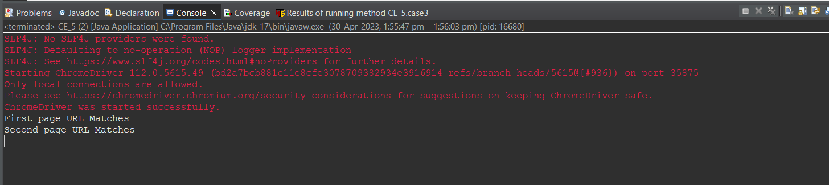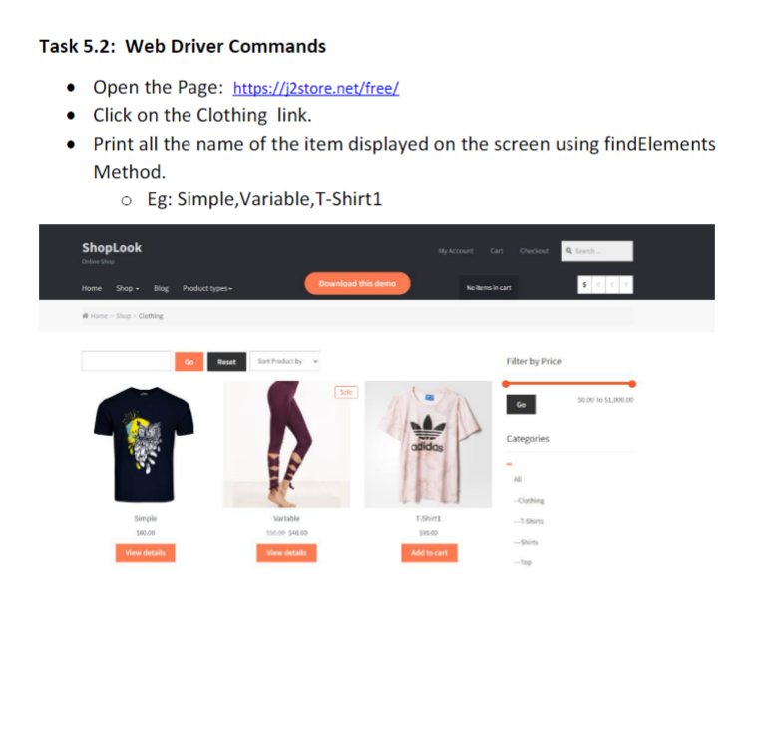

**CODE :**

package com.day4;

import java.util.List;

import org.openqa.selenium.By;

import org.openqa.selenium.WebDriver;

import org.openqa.selenium.WebElement;

import org.openqa.selenium.chrome.ChromeDriver;

import org.openqa.selenium.chrome.ChromeOptions;

import io.github.bonigarcia.wdm.WebDriverManager;

public class CE_5_2 {

public static void main(String[] args) {

ChromeOptions co = new ChromeOptions();

co.addArguments("--remote-allows-origins=*");

WebDriverManager.chromedriver().setup();

WebDriver driver = new ChromeDriver();

driver.get("https://j2store.net/free/");

driver.manage().window().maximize();

driver.findElement(By.linkText("Clothing (5)")).click();

List<WebElement> items = driver.findElements(By.xpath("//h2[@itemprop=\"name\"]")); //findElement"s"

for(int i=0;i<items.size();i++)

{

System.out.println(items.get(i).getText());

}

}

} **OUTPUT :**

